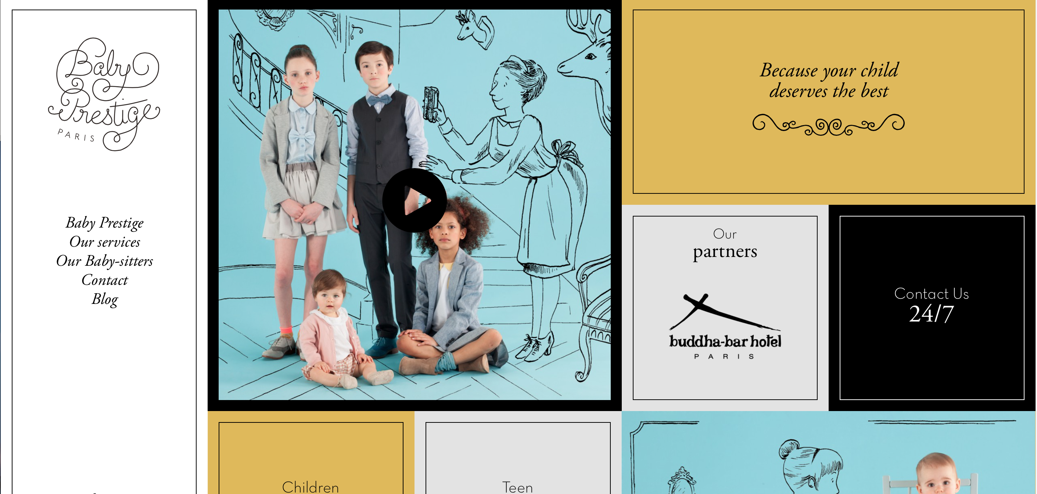

The header for this website is along the whole left side, which I think is very catchy. It is a static feature that scrolls along with the rest of the page. This site uses a very upbeat color pallet and some curly font to catch the user’s attention. The contact box is toward the middle in a simple black box with white text, classy. That is what this whole company is about, class. The tagline at the top specifically states that, “Because your child deserves the best”.

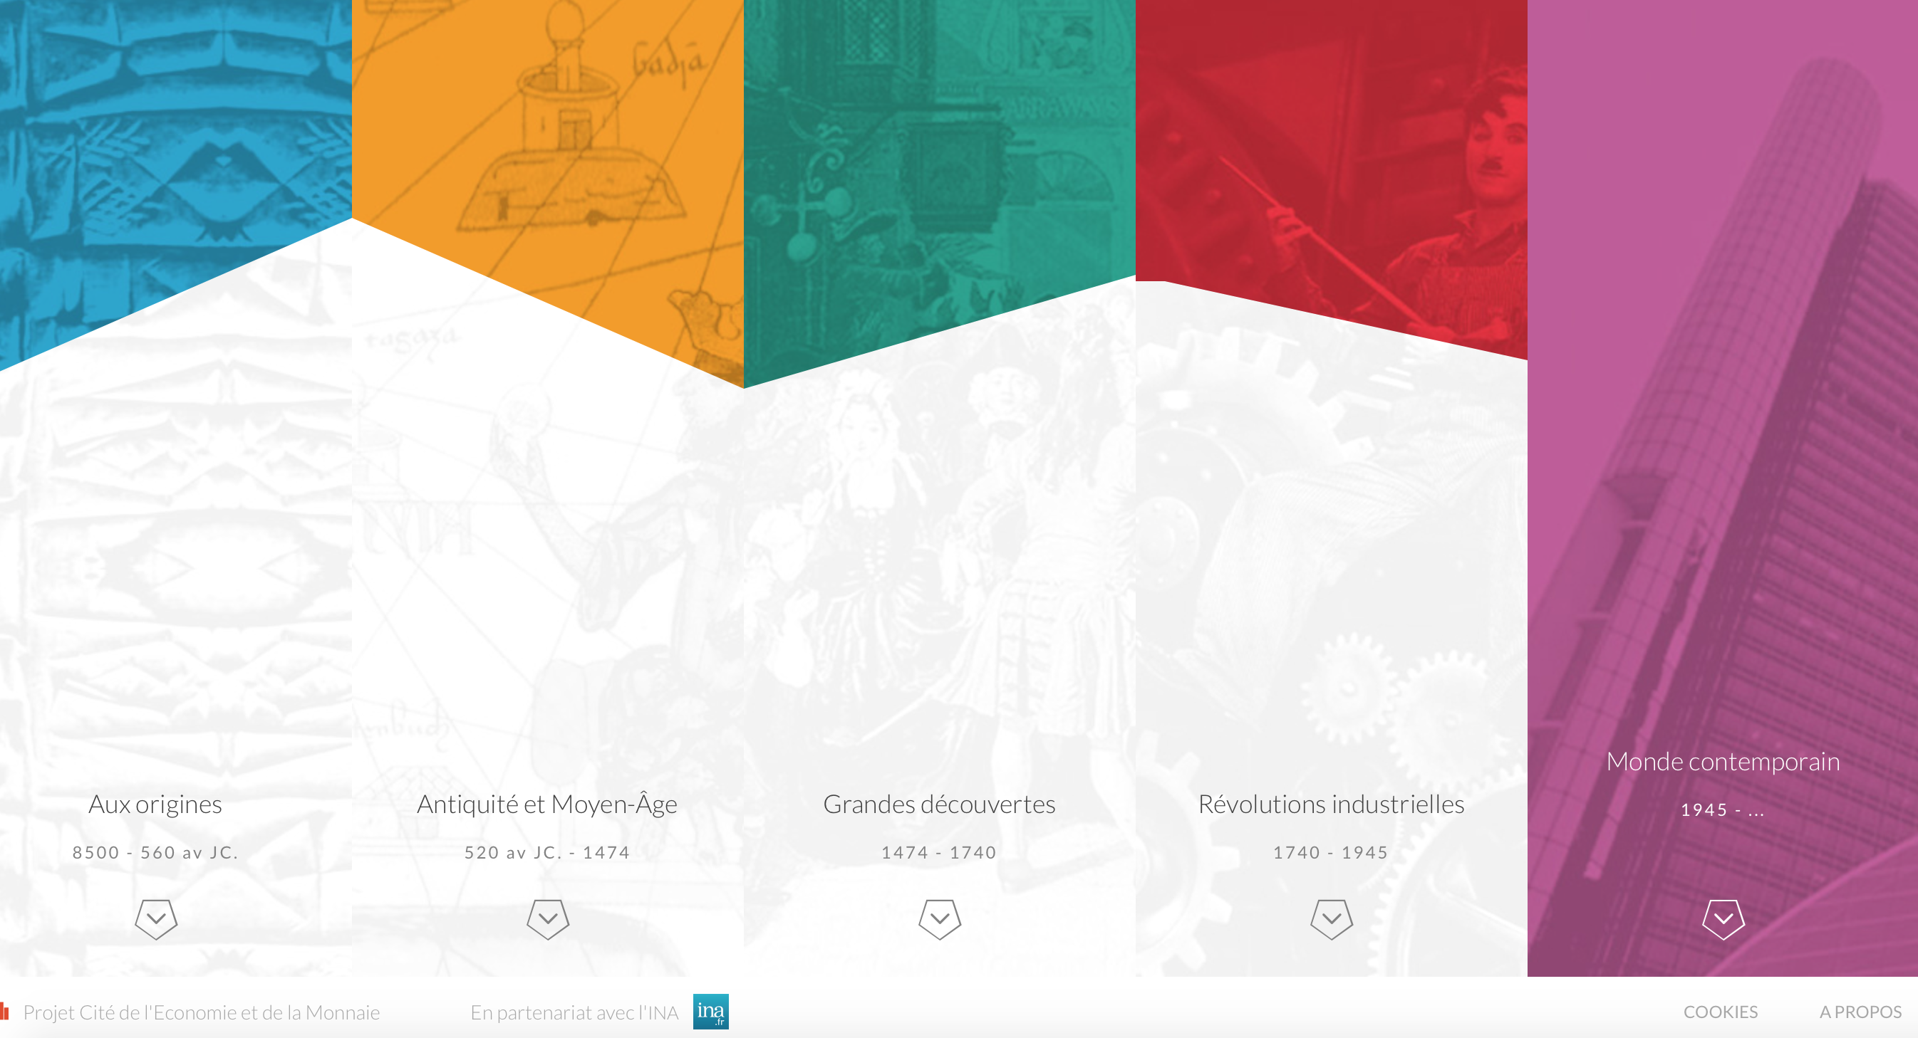

The header for this page is pretty cool. A “cut up” look along the top brings the user to the different categories offered by the site. An arrow at the bottom uses the mouseover function to bring the color all the way down. (as shown above)

This page is written in a foreign language so I’m not exactly sure what they offer.

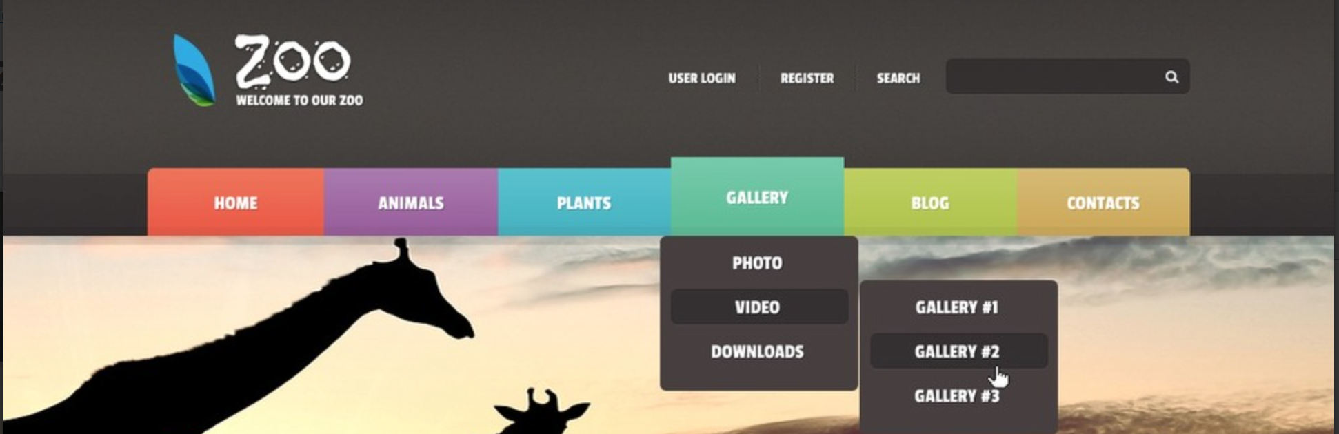

I love the simplicity and color of this header. A rainbow of choices drop down to simple black menus. Once again, this is a site for a zoo. Users would be drawn in by the use of majestic animal images. A really cool font is used in the logo, it has almost a tribal feel to it.

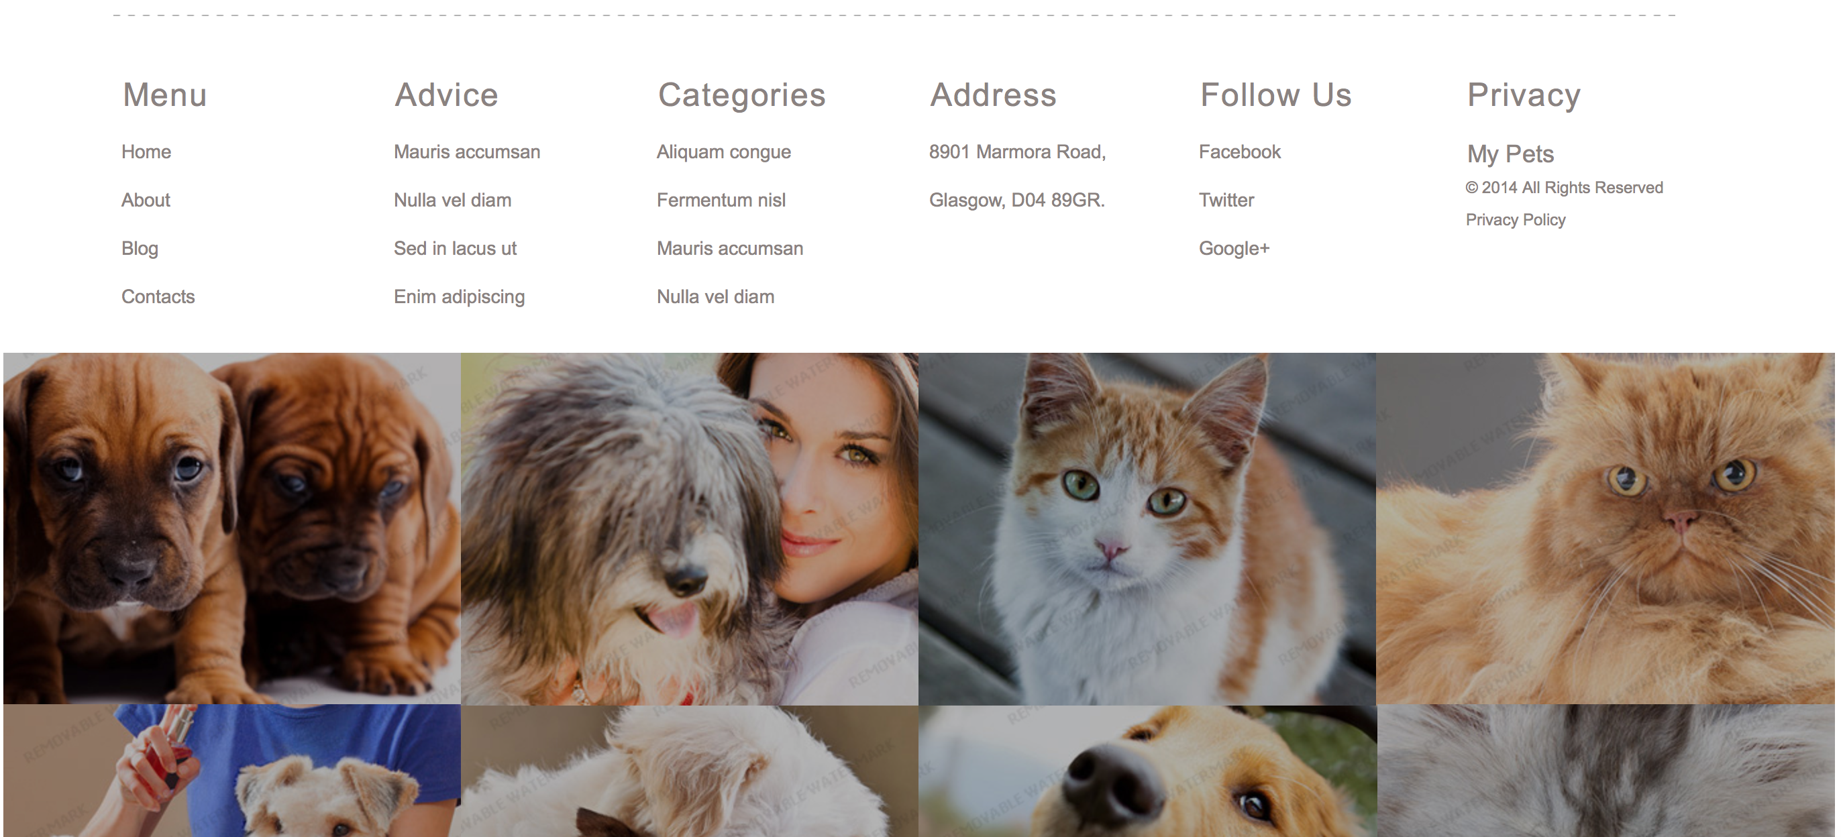

The footer for this webpage is awesome. A simple photo gallery at the bottom. There is no text or buttons, just a clean grid of square photos that light up when moused over to show they are clickable. An image pops up in a separate window of these animals. Once again, there is no text, just a photo of the beautiful creatures.